Dependency Syntax

Source: https://people.ischool.berkeley.edu/~dbamman/nlp20_slides/16_dependency_syntax.pdf

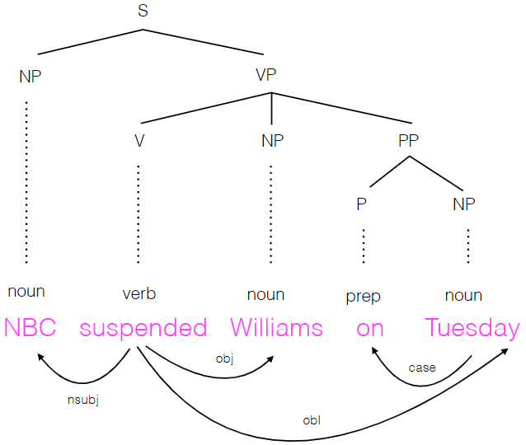
Dependency
- Words directly linked to each other
- Need to determine head/dependent words in a pair
- Expressed in dependency tree which are non-linear in order compared to sentence
- Dataset: NELL SVO triples

